CEN 3.1 A

**SawyerAir**

# **Software Design Document**

Names: Andronie Bertha, Avram Vlad Andrei, Stinga Adelin Alexandru

Lab Section: Software Engineering Laboratory

Date: 26.03.2021

**TABLE OF CONTENTS**

1. INTRODUCTION 2
   1. Purpose 2
   2. Scope 2
   3. Overview 2
   4. Reference Material 2
   5. Definitions and Acronyms 2
2. SYSTEM OVERVIEW 2
3. SYSTEM ARCHITECTURE 2
   1. Architectural Design 2
   2. Decomposition Description 3
   3. Design Rationale 3
4. DATA DESIGN 3
   1. Data Description 3
   2. Data Dictionary 3
5. COMPONENT DESIGN 3
6. HUMAN INTERFACE DESIGN 4
   1. Overview of User Interface 4
   2. Screen Images 4
   3. Screen Objects and Actions 4
7. REQUIREMENTS MATRIX 4
8. APPENDICES 4

### INTRODUCTION

## Purpose

This software design document provides the architecture and system design details of SawyerAir, a web application. Its main purpose is to describe the use cases already detailed in the software requirements specification document.

The intended audience consists of developers, project managers, testers and the people who will maintain SawyerAir. The other intended audience consists of the customers that will make use of the application.

## Scope

This document contains a complete description of the design of SawyerAir.

The basic architecture is a web application. The basic pages will be in Html, Css, Bootstrap and Javascript.

SawyerAir addresses the management of flights operations at an airport. The main purpose of this product is to better manage the flow of customers in the airport by introducing the booking option. Using this application, a customer can view all available flights that the airport provides and can make a booking for one or many flights.

## Overview

The document contains 7 main parts :

PART 1 consists of a short description of the web application ( references, definitions, acronyms ).

PART 2 is a short description of the system.

PART 3 addresses the Architectural Design that specifies the design entities that collaborate to perform all the functions included in the systems.

PART 4 concerns the Data Structure Design.

PART 5 contains the Use Case Realizations.

PART 6 discusses the User Interface Design, and how it can be created with a good efficiency and ease of use.

PART 7 covers the requirements matrix.

## Reference Material

<https://en.wikipedia.org/wiki/Flight_management_system>

<https://www.youtube.com/watch?v=C5cnZ-gZy2I>

https://docs.microsoft.com/en-us/aspnet/core/tutorials/first-mvc-app/start-mvc?view=aspnetcore-5.0&tabs=visual-studio

<https://wizzair.com/ro-ro#/>

## Definitions and Acronyms

Database = organized collection of [data](https://en.wikipedia.org/wiki/Data_(computing)), generally stored and accessed electronically from a computer system.

Interface = shared boundary across which two or more separate components of a [computer system](https://en.wikipedia.org/wiki/Computer_system) exchange information. The exchange can be between [software](https://en.wikipedia.org/wiki/Software), [computer hardware](https://en.wikipedia.org/wiki/Computer_hardware), [peripheral](https://en.wikipedia.org/wiki/Peripheral) devices, [humans](https://en.wikipedia.org/wiki/User_interface), and combinations of these.

User = any person who interacts and makes use of the application.

FMSP = Flight Management System Project

### SYSTEM OVERVIEW

The FMSP, SawyerAir, is a standalone system that provides the following described functionalities.

Product Functions :

* Provides a login method for the customers.
* Provides a security system with password.
* Provides the option to reset the password.
* Provides the option for the customers to book one or many flights.
* Provides the option to browse through the available flights.
* Provides the option to choose the payment method.
* Provides a database to keep track of the customers data and the flights information.

It includes all subsystems needed to fulfill these software requirements.

The system will consist of a web application used fot the management of every flight in an airport.

Use case:

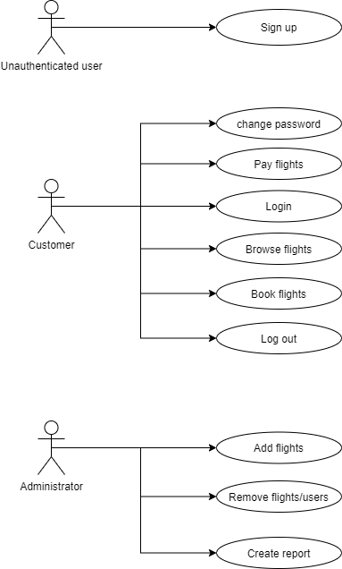

### SYSTEM ARCHITECTURE

## Architectural Design

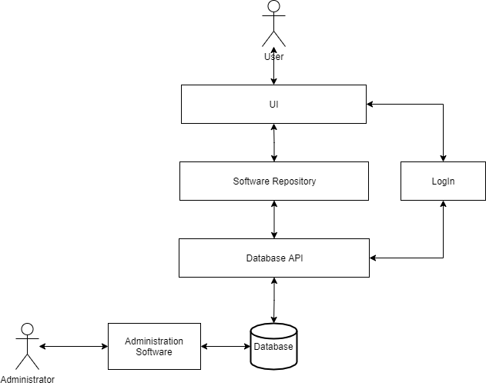

## Decomposition Description

Customer Flow Chart Diagram

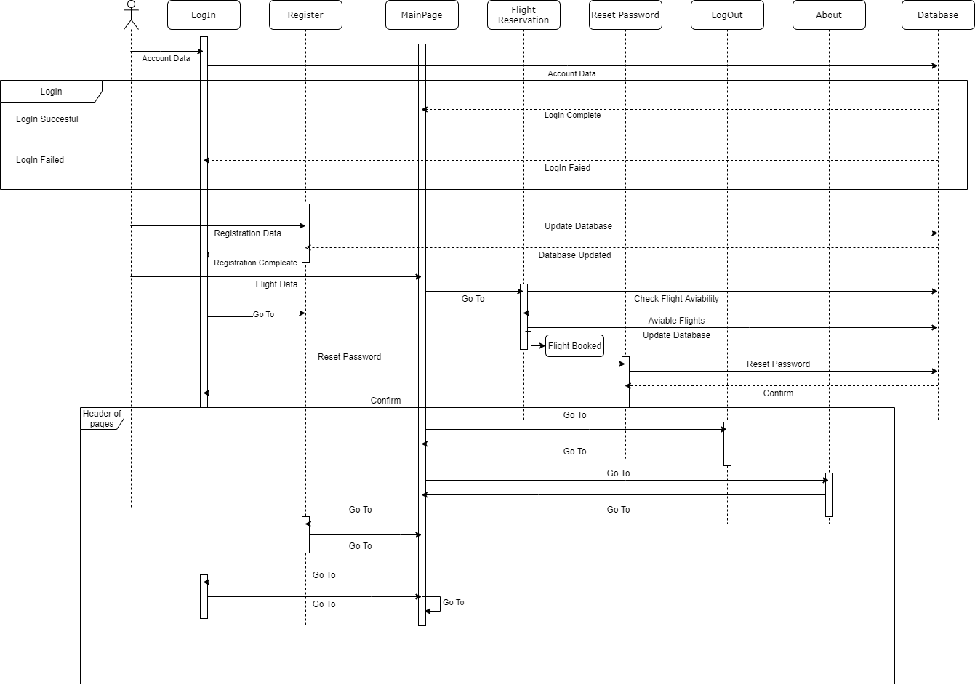

The “Header of pages” part is found on all the pages.

Administrator Flow Chart Diagram

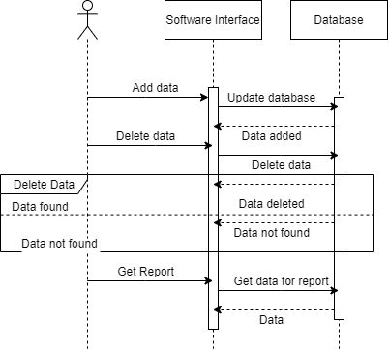

## Design Rationale

The will have 3 main parts:

1. The web application used by the customers to register, update their account, log in, search and buy tickets on a flight;
2. A desktop application used by the administrator to input flight data, remove flights and get a report;
3. The Database and API used to communicate with the modules 1 and 2.

### DATA DESIGN

## Data Description

The database has 6 entities used for the development of the application:

* Client: this is where all the personal information about the user is saved
* Booked: here are the details about each flight booked by a specific user
* Flight: here are all the information about the flight
* Stop: here are all the possible stops that a plane can make during a flight
* Plane: here are some brief identification info about the plane
* Airport: here is stored the location of the airport where the flights will take of

## Data Dictionary

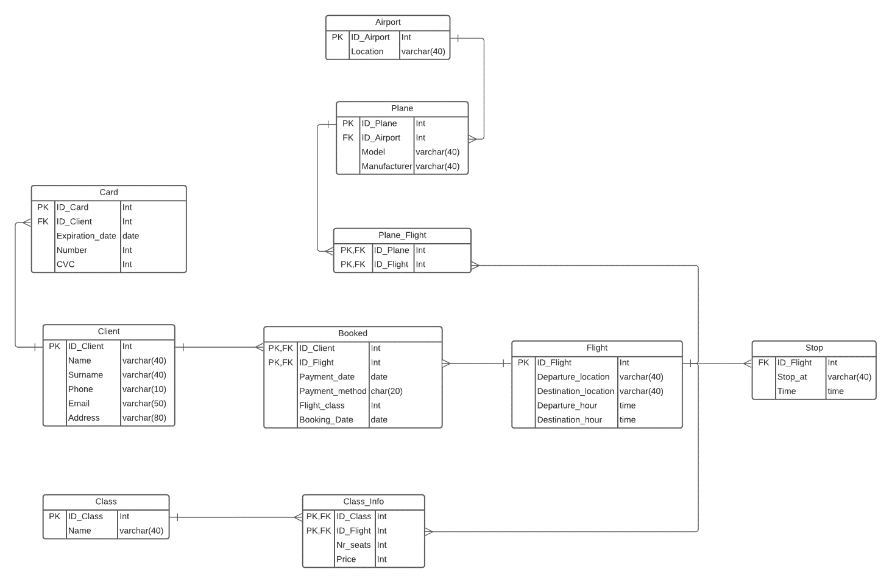

### COMPONENT DESIGN

Login:

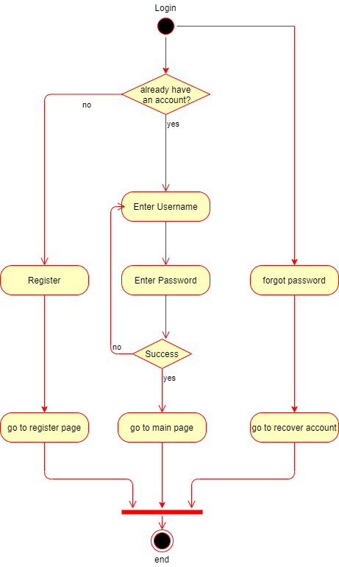

Register:

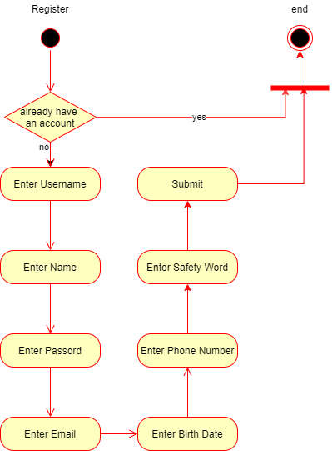

Book/Browse flights:

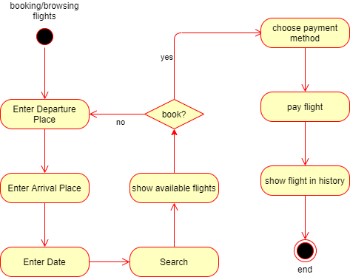

Forgot password:

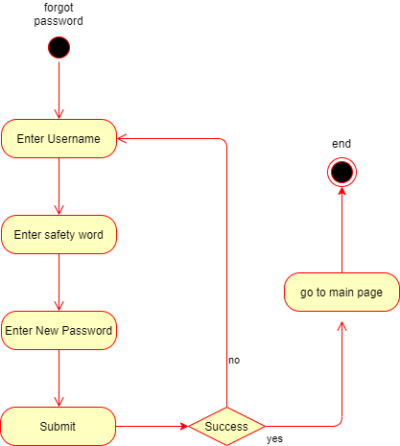

Change Password:

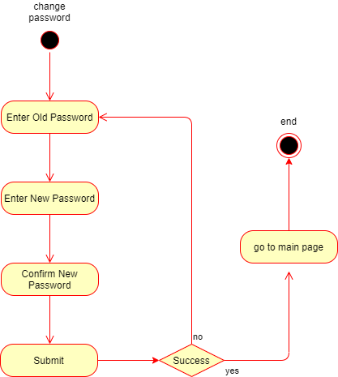

Log out:

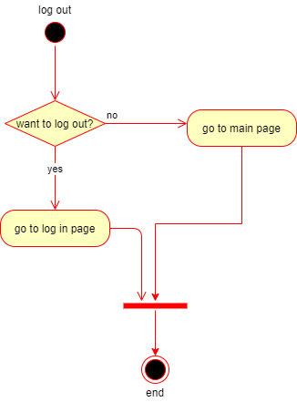

### HUMAN INTERFACE DESIGN

## Overview of User Interface

The user interface is highly intuitive with a simple design to login or sign in the web application and to offer an easy time browsing through flights.

When a customer first accesses the application, he is prompted to the home page. The header contains the name, motto and a navigation bar consisting of buttons to all pages ( login, registration, log out, booking, about ). Taking another look on this page, there is presented a table that provides information about all available flights but also three search boxes, very useful for the users. By introducing the wanted destination, departure and date, the customer can filter all flights in order to access only the desired potential ones.

The Booking Page also contains the navigation bar, the company’s motto and scope of the page. It contains only the flights that correspond to the previously entered criteria. From this on, all there is left is to pick a flight and book it.

The Login Page offers the user the option to log into their existing account. In case of forgotten password, the client also has the option to go to the Reset Password Page.

The Reset Password Page provides the customer the option to reset its password very easily. This can be done by entering a security word used at registration and the new desired password.

The Register Page gives the user the option to create an account in order to access and make use of the web application.

The About Page consists of a series of announcements, news and general informationl.

The Log Out Page provides the user the option to log out from their account.

## Screen Images

HOME PAGE :

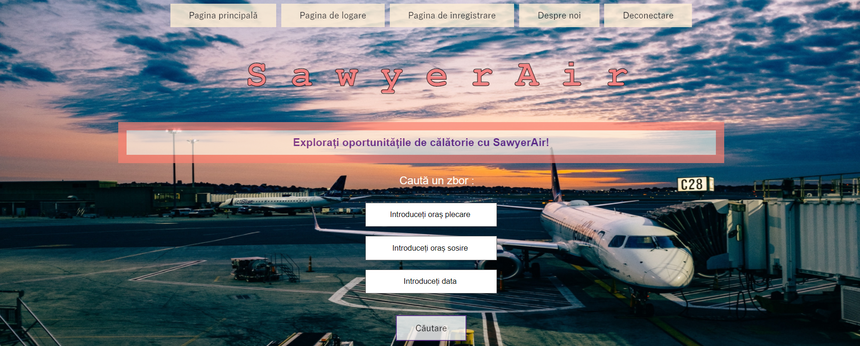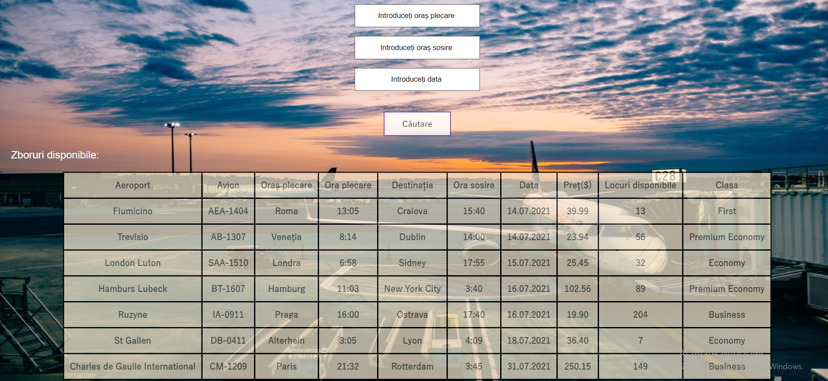

LOGIN PAGE :

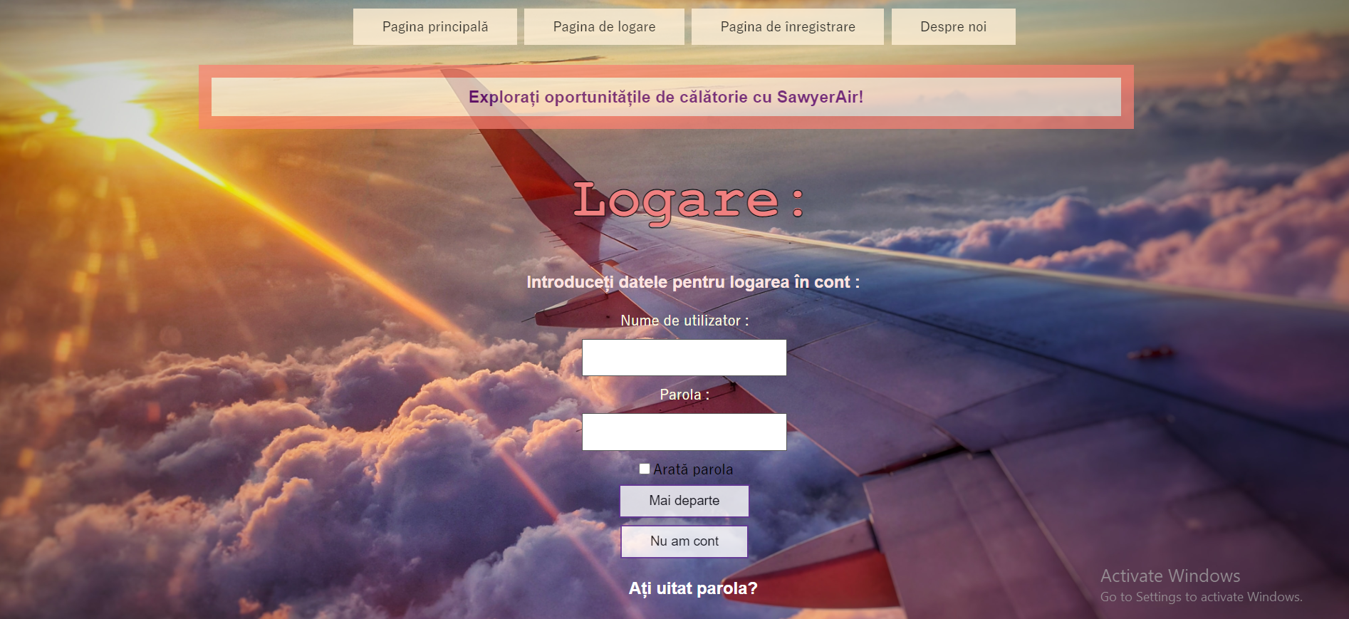

RESET PASSWORD PAGE :

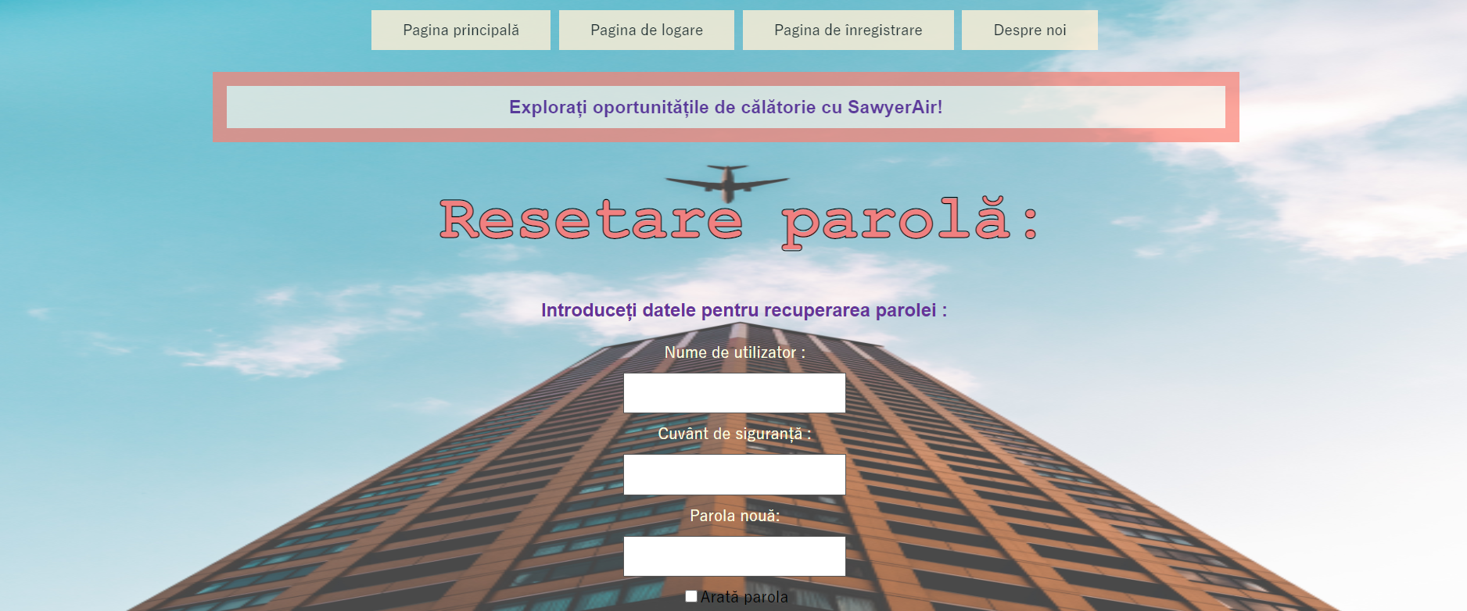

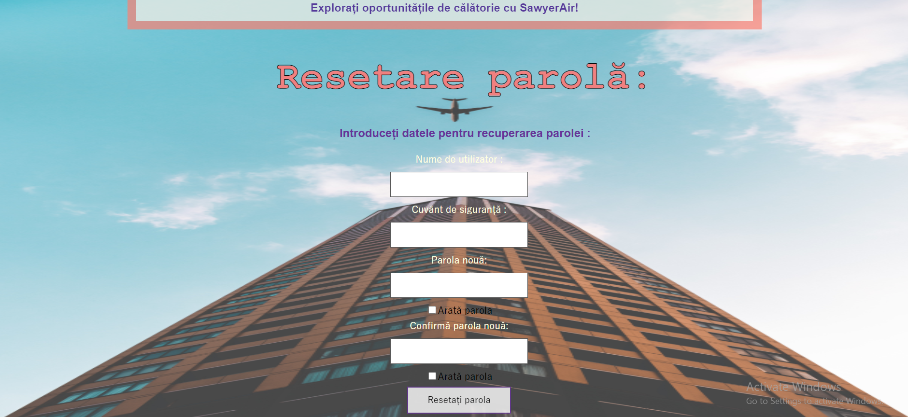

REGISTRATION PAGE :

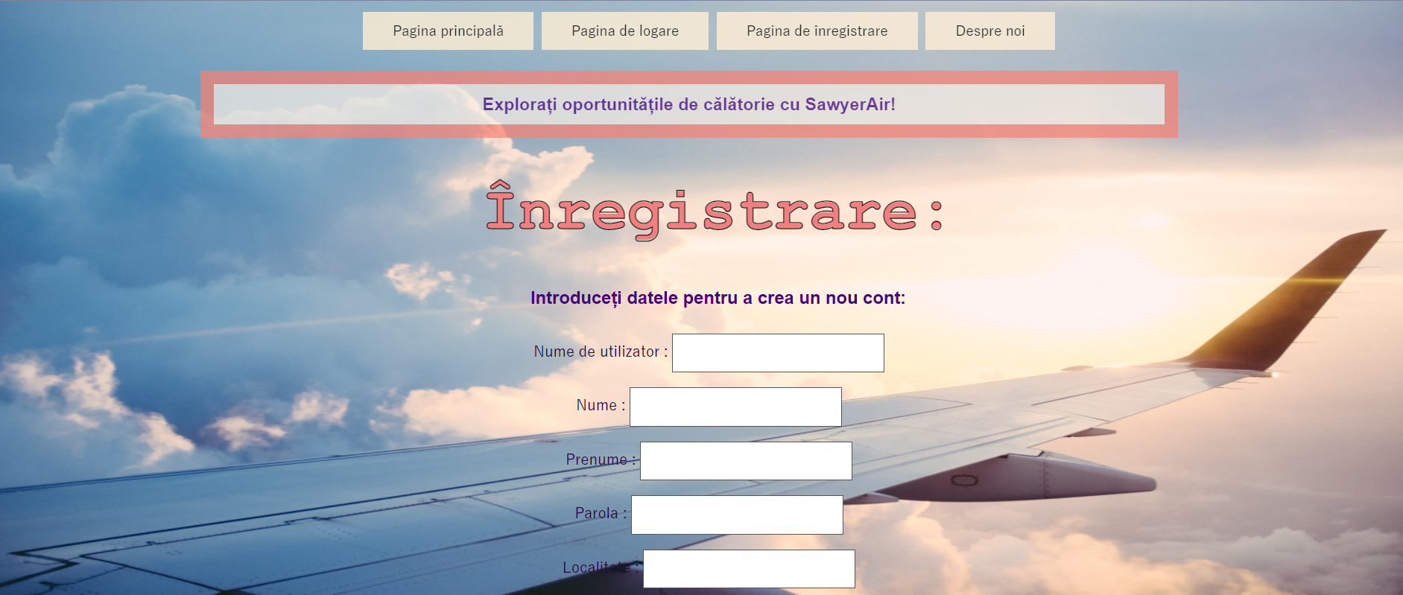

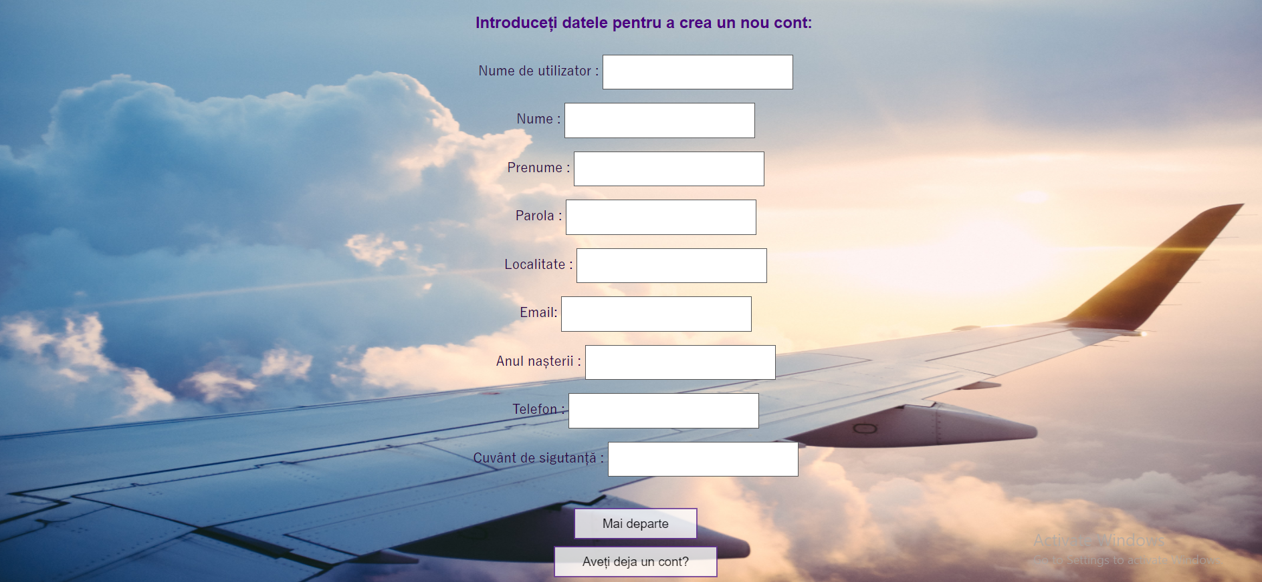

LOG OUT PAGE 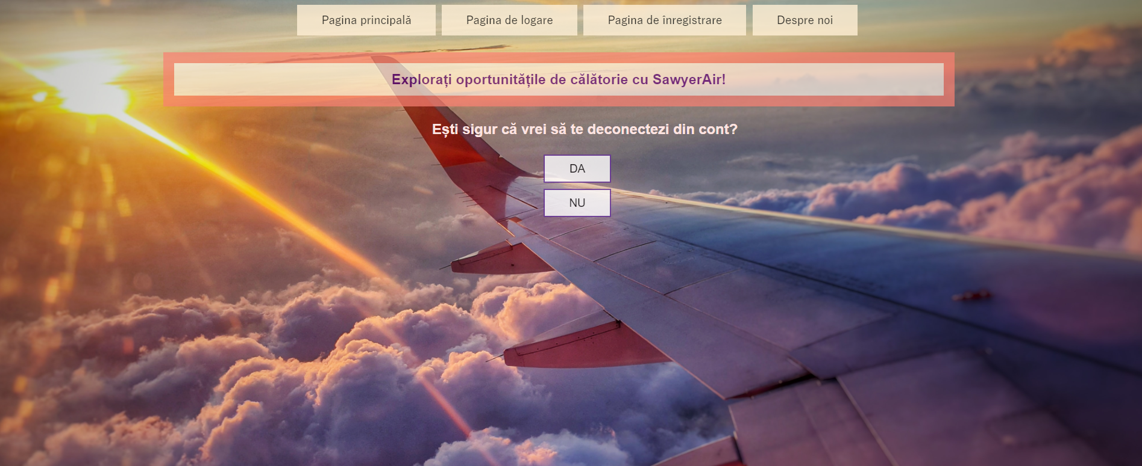

ABOUT PAGE :

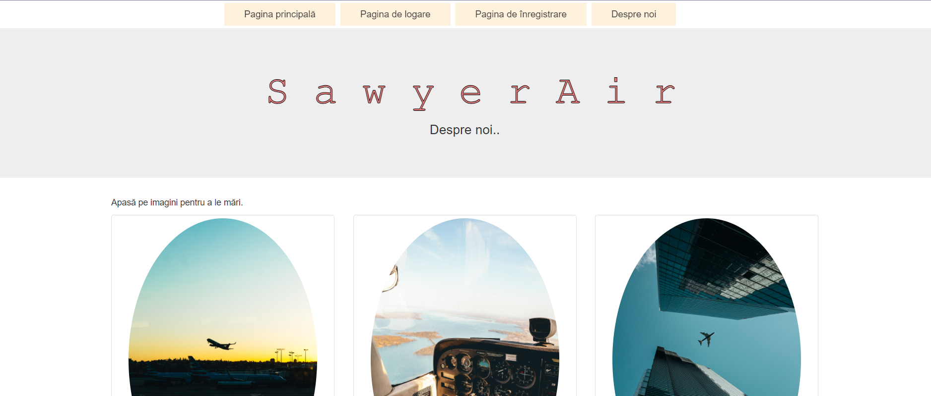

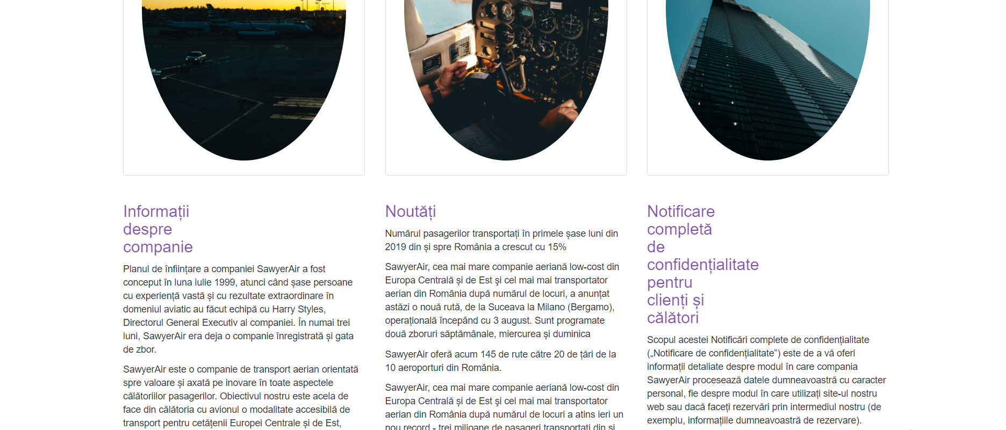

BOOKING PAGE :

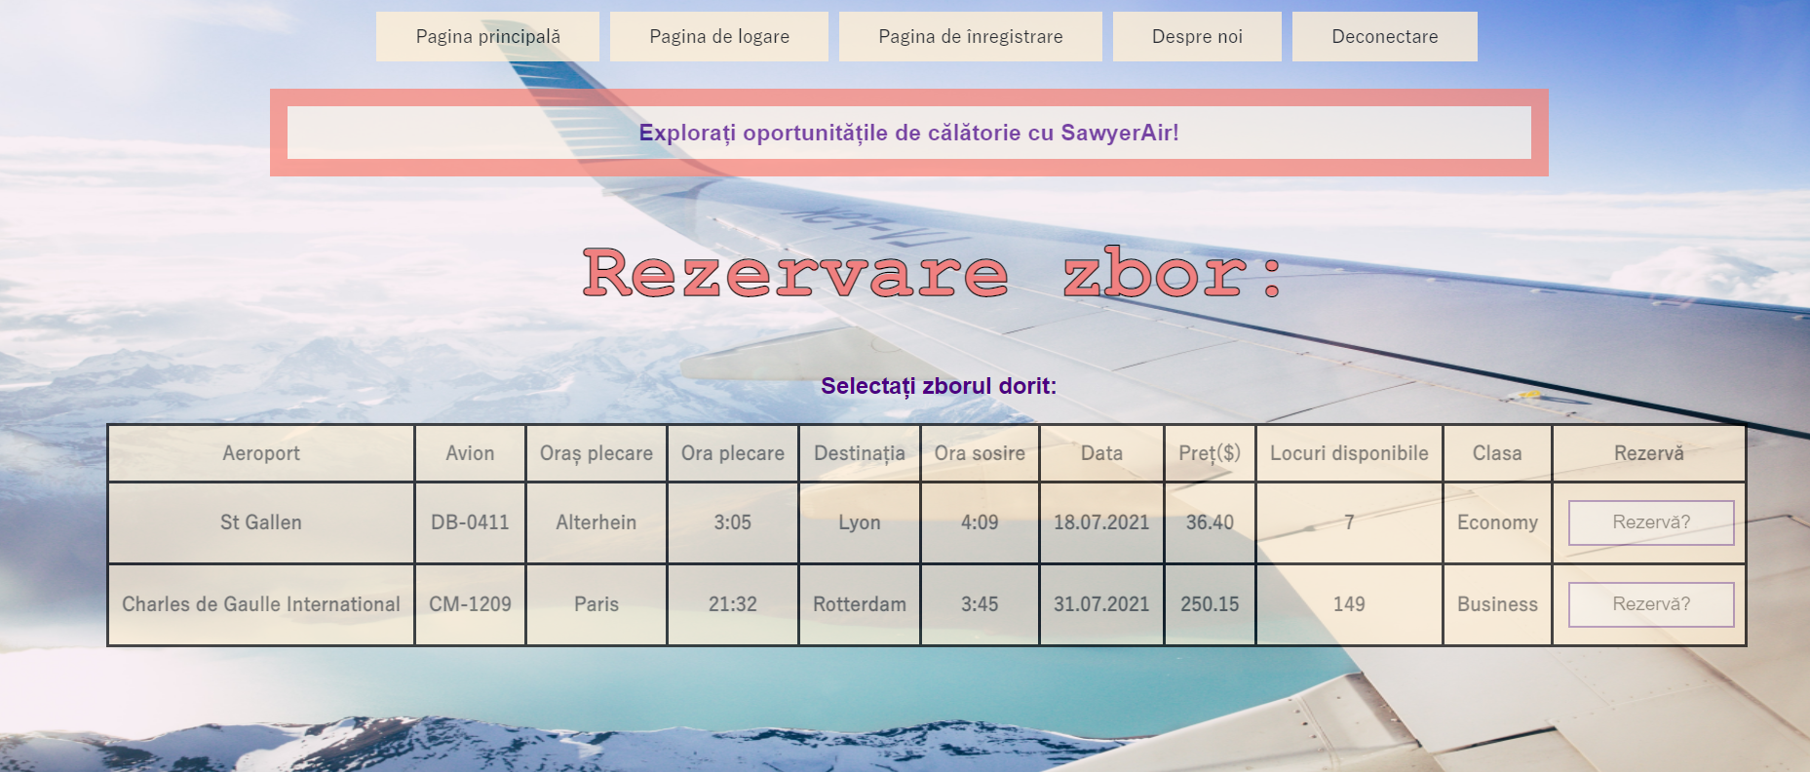

**6.3**. Screen Objects and Actions

Home page: The navigation bar consisting of the followings : “Pagina de logare” which prompts the user to the login page; “ Pagina de inregistrare” which prompts the register page; “Deconectare” that brings the customer to the log out page; “ Despre noi “ which prompts the client to the about page; “ Pagina principala “ that brings the user back to the home page. Clicking on “ Cautare “ after introducing desired data brings the user to the Booking Page.

Booking page : Clicking on “Rezerva” books the chosen flight by the customer and shows a message on the screen : “ Successful booking ! “ .

Login page : Introducing the username and the password into each input box logs the customer into its account. Clicking on the checkbox “ Arata parola “ makes the hidden password visible. Clicking on the button “ Mai departe”, the customer submits the credentials and it’s then directed to the home page in order to browse through the available flights. Clicking on the button “ Nu am cont “ prompts the user to the Register Page. Clicking on text “ Ai uitat parola ?” brings the customer to the Reset Password Page.

Register page : Introducing basic information to create an account. Clicking on the button “ Mai departe”, the customer submits the credentials and it’s then directed to the login page in order to log into newly created account. Clicking on the button “ Ai deja cont?” also prompts the user to the login page in order to log into existing account.

Reset Password page : Introducing security keys and new desired password for the account. Clicking on the checkbox “ Arata parola “ makes the hidden password visible.

Logout page : There are two buttons, depending if the user wants to log out “ DA “ , which logs out the user from its account, or “ NU “ if the user does not actually want to log out from their account.

### REQUIREMENTS MATRIX

